1. go to website <http://tomcat.apache.org/download-70.cgi> and download Tomcat Binary Distribution zip file:

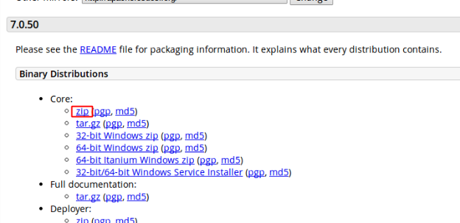

2. After download complete, unzip file.

3. In Netbeans, in Services tab, right click Servers and select Add Server:

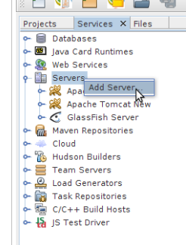

4. In Add Server Instance, choose Apache Tomcat and rename server name, then click Next:

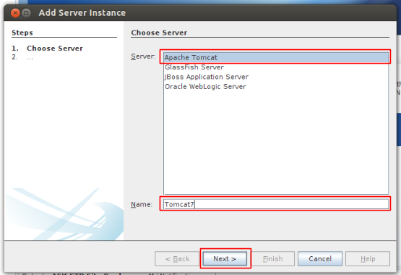

5. Enter the location where unzip tomcat locate, and create a Username and Password, then click Finish:

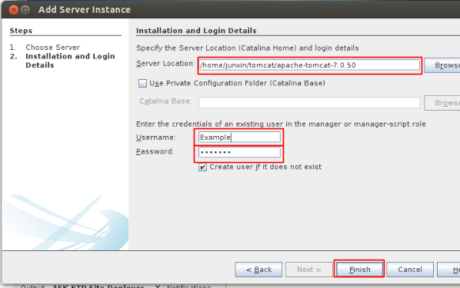

6. Right Click new Tomcat Servers and click start.

7. If you get an error stating “... unable to execute catalina.sh …”, go to the directory where tomcat was unzipped, and then to its subdirectory bin, and “chmod 755 \*.sh”

\*\*\*\*\*\*\*\*\*\*\*\*\*\*\*\*\*\*\*\*\*\*\*\*\*\*\*\*\*\*\*\*\*\*\*\*\*\*\*\*\*\*\*\*\*\*\*\*\*\*\*\*\*\*\*\*\*\*\*\*\*\*\*\*\*\*\*\*\*\*\*\*\*\*\*\*\*\*\*\*\*\*\*\*\*\*\*\*\*\*\*\*\*\*\*

If Server Port and Shutdown Port has been used by other servers. Go to unzip Tomcat address, where should be similar : …./apache-tomcat-7.0.50/conf/ Then, use text editer open server.xml file.

If Server Port has been used, go to lines :

<Connector port="8080" protocol="HTTP/1.1"

connectionTimeout="20000"

redirectPort="8443" />

Then change 8080 to an unused port, such as 8090, then Save.

If Shutdown Port has been used, go to lines:

<Server port="8005" shutdown="SHUTDOWN">

Then change 8005 to an unused port, such as 8020, then Save.